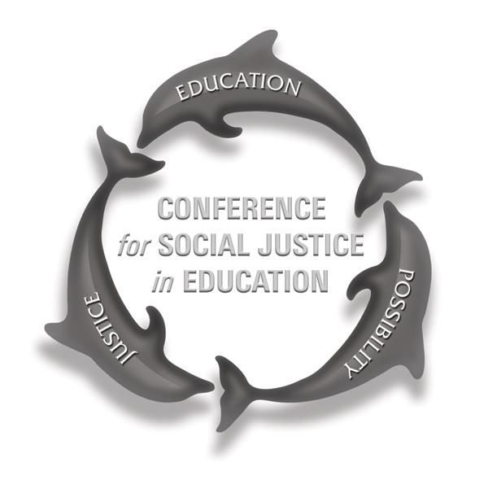
Proposal to Present
11th Annual Conference for Social Justice in Education
Grand Salon, California State University Channel Islands
Saturday, April 6, 2019, 8:00am-2:00pm
Be the change: Social justice in and through education in
the post-truth Era

To submit, please complete all sections below and either:
- Email your completed form to lauren.miller@csuci.edu OR
- Mail it to: Lauren Miller, CSU Channel Islands, One University Drive, Camarillo, CA 93012.

Please submit this form by 11:59 pm on Monday, 2/04/2019.

Title of presentation:

Type of Presentation: Describe how you envision the structure of this session (e.g., research presentation, panel discussion, promising practices in schools/classrooms, storytelling, performance)

Name(s) of presenter(s), along with each person’s organizational affiliation, if any:

Phone/email/address for main contact person:

Session description: Please provide a description of your presentation, up to 500 words long, highlighting what your audience will experience and learn during your proposed hour-long session.

Proposals will be evaluated by how clearly and thoroughly they address one or more of the following:
- Reclaiming the promise of education: Connecting current events with “Be the Change: Social Justice in and through Education in a Post-Truth Era”
- Supporting one system to serve the whole child: Understanding “the California Way” and a culture of continuous improvement (e.g., What are the school policies and practices that promote performance vs. accountability? How do recent policy changes in California, such as the Local Control Funding Formula, California School Dashboard, Multi-Tiered System of Support, and others, serve the causes of equity and justice?)
- Purpose and design of education: What is it? What does a well-rounded education require? What purposes must education serve in a democratic society? How do these ideas connect with being the change in a post-truth era?
- Prevention and intervention efforts, programs, strategies, and pedagogies (e.g., restorative justice, social and emotional learning in schools, fostering resilience, understanding the promise and perils of free speech in P12, higher education, and in the community)
- Supporting vulnerable populations (e.g., foster youth, people in poverty, migrant youth and families, people of color, LGBTQ+ individuals, students with disabilities)
- Stories of hope: People, programs, and systems that work

Which of the above will your session address? How? Provide your description here:

Abstract for the Conference Program: Please provide a 75-100 word description of your presentation as you would like it to appear in the conference program. Keep in mind that this is your pitch, your invitation for conference attendees to select your session, and that many attendees are high school and university students.

Language(s): In what language(s) will you present?

Accommodations: Please describe any special needs you or your co-presenters may require.

Audience: Who do you believe would most benefit from attending your presentation?

Miscellaneous: Is there anything else we should know about you, your presentation, or your work?

A/V availability: Each classroom will have an LCD projector and PC desktop computer, whiteboard(s), and dry erase markers. If you require any equipment or materials beyond this, you will need to provide it.

