Request for Proposals (RFP) to Present (proposals due 11:59 pm, February 4, 2019)
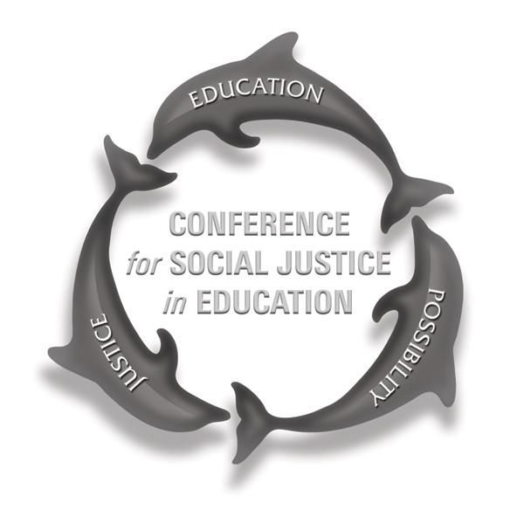
Be the Change: Social Justice in and through Education in a Post-Truth Era
April 6, 2019

11th Annual Conference for Social Justice in Education
California State University Channel Islands

See http://education.csuci.edu/justice-conference/ to register for this free event. (Lunch and parking are provided for all registered attendees.)

Keynote Address: Danna Lomax, Ventura Unified School District, Recipient of the
2018 Teaching for Tolerance Award for Excellence in Teaching

The School of Education at Channel Islands (CSUCI) invites you to submit a proposal to present at the 11th Annual Conference for Social Justice in Education. The daylong conference, offered at no cost to participants, will be held on Saturday, April 6, 2019 (8:00 am to 2:00 pm) on the campus of CSUCI. The purpose of the annual event is to showcase the social justice oriented work being done in and around schools and educational institutions in the region, to network with others who believe in the power and necessity of such work, and to learn from one another about how best to teach and learn in ways that promote equity, peace, and integrity in public education.

This year’s theme is Be the Change: Social Justice in and through Education in a Post-Truth Era. The theme builds on the powerful scholarship of previous conferences and highlights the essential process of networking, of building a common agenda, and of creating opportunities for collaborative impact to achieve social justice by and through education.

Our vision is that this year’s conference will provide attendees with opportunities to have thoughtful conversations about research, policies, and practices that either undermine or advance the goal of achieving social justice in and through education. The conference is a venue for critical thinking and sharing insights into what works – and to inspire all of us to collaborate in moving that work forward. Participants will walk away with: (1) greater understanding of the research, policies and practices that undermine or advance social justice in and through education; (2) ideas for action and opportunities to pursue reforms to create equitable learning opportunities for all students; (3) connections with others in the community who are working toward social justice in education.

Proposals will be evaluated by how clearly and thoroughly they address policies and/or practices in one or more of the following areas of P12 and/or higher education.
- Reclaiming the promise of education: Connecting current events with “Be the Change: Social Justice in and through Education in a Post-Truth Era”
- Supporting one system to serve the whole child: Understanding “the California Way” and a culture of continuous improvement (e.g., What are the school policies and practices that promote performance vs. accountability? How do recent policy changes in California, such as the Local Control Funding Formula, California School Dashboard, Multi-Tiered System of Support, and others, serve the causes of equity and justice?)
- Purpose and design of education: What is it? What does a well-rounded education require? What purposes must education serve in a democratic society? How do these ideas connect with being the change in a post-truth era?

- Prevention and intervention efforts, programs, strategies, and pedagogies (e.g., restorative justice, social and emotional learning in schools, fostering resilience, understanding the promise and perils of free speech in P12, higher education, and in the community)
- Supporting vulnerable populations (e.g., foster youth, people in poverty, migrant youth and families, people of color, LGBTQ+ individuals, students with disabilities)
- Stories of hope: People, programs, and systems that work

Accepted proposals may be considered for publication in Allies for Education (A4E), CSUCI’s journal connecting parents, educators, students, and other community members in conversation about research and other important topics in education. To the greatest extent possible, A4E works are published in English and Spanish.

Frequently Asked Questions

Who is invited to submit a proposal?
Students of all ages, P12 teachers, university faculty, students, parents, grandparents, administrators, professors, counselors, social workers, school psychologists, coaches, community-based educators, activists/organizers, artists, community leaders—basically, anyone who cares about teaching and learning in and out of school and whose work is devoted to promoting some aspect of social justice.

Interested in presenting at this year’s conference?
- Download the presentation proposal form at http://education.csuci.edu/justice-conference/proposal-info.htm.
- Proposals to present are due by 11:59 pm on Monday, February 4, 2019. Email your completed proposal to Lauren Miller at lauren.miller@csuci.edu
- The status of your proposal will be communicated to you no later than Friday, March 1st, 2019 using contact information you supply on your proposal.

What types of presentations are encouraged?
All kinds of presentations are welcome. The important thing is to make sure your proposed presentation is clearly designed to promote social justice in/through education and is clearly connected to the conference theme. Possible kinds of presentations:
- Sharing your activism/social justice stories: describing how you worked individually or organized with others to raise awareness, resist injustice, or promote equity in education, and how that work is related to the conference theme
- Panel discussion: bringing together various speakers to discuss a specific topic related to the conference theme
- Research: sharing what you learned when you investigated a topic related to the conference theme and gathered data about it
- Performance: spoken word, paintings, graphics, dance, plays, music — anything you want to perform for others that relates to the conference theme
May I/we submit a proposal and present a session in a language other than English?
We enthusiastically encourage multilingual presentations and presenters.

Can I just attend the conference even if I don’t present?
Please do, and bring friends! Attendance is free and open to the public. Register online at http://education.csuci.edu/justice-conference/registration.htm. Walk-ins can register at the event on April 6 at 8:00 on a space-available basis, but we encourage online registration so we can plan efficiently for lunch (which will be provided free of charge by conference sponsors).
Where can I get more information?
Check the website: http://education.csuci.edu/justice-conference/faq.htm or contact Lauren Miller at lauren.miller@csuci.edu or (805) 437-3943.

